11/20 R課堂練習

0513250 邱郁雯

(a) Facet and smooth with the iris data

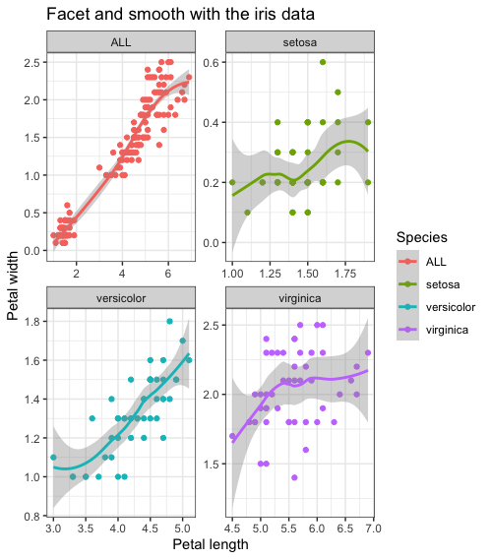

(b) Bubble-plot (scatter diagram) with mtcars

